**Machine Learning Assignment 2**

**Aparna Pavithran**

**Naïve Bayes**

**Example 1:**

With out removing stop words: -

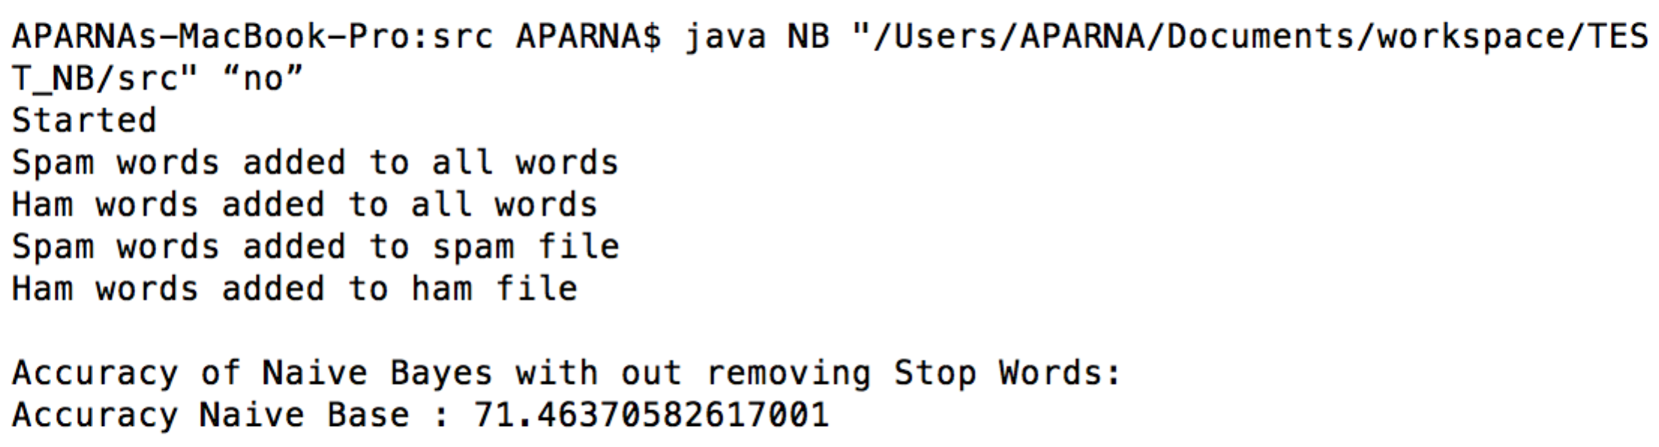

**Example 2:**

By removing stop words: -

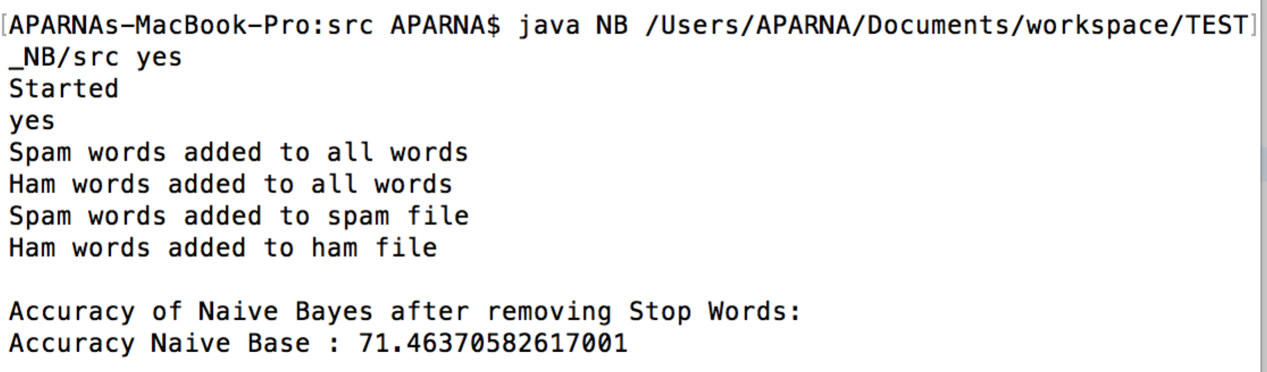

**Logistic Regression**

**Example 1:**

Learning rate = .1

Lambda =.89

Iteration = 1

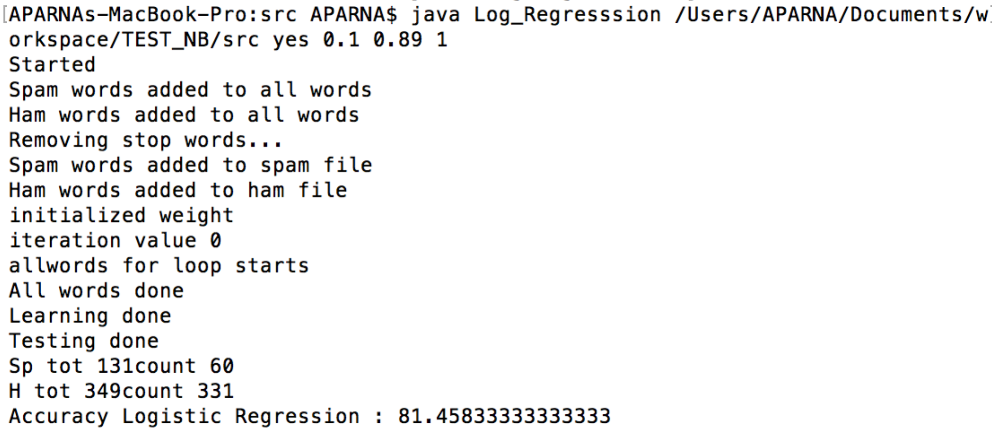

Iteration = 2

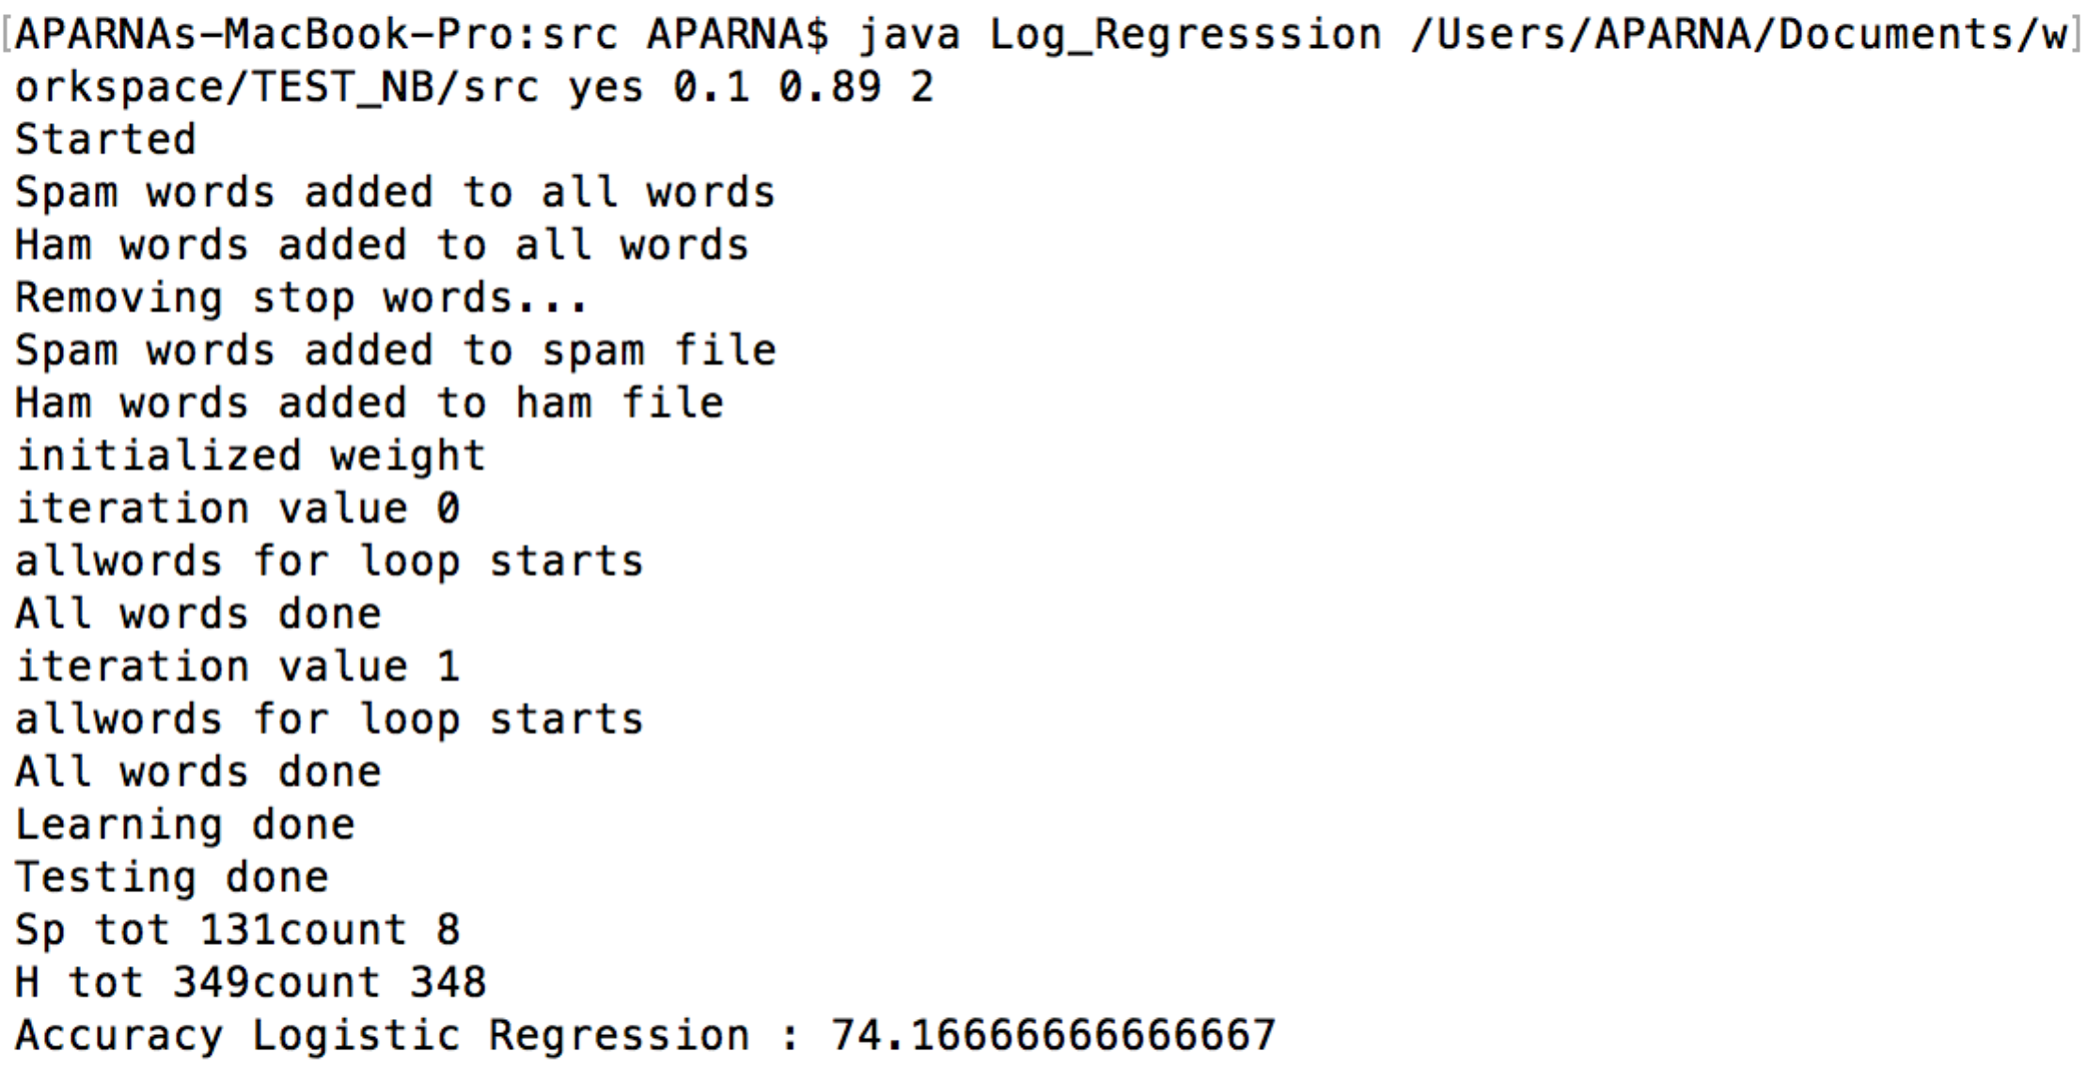

Iteration = 3

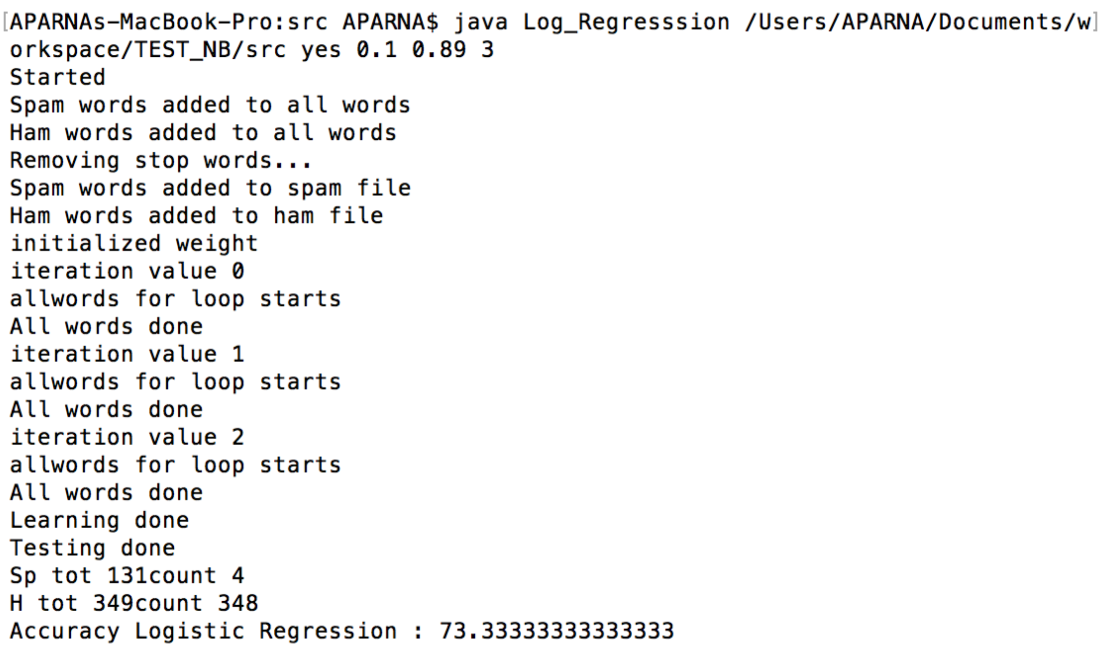

Iteration = 4

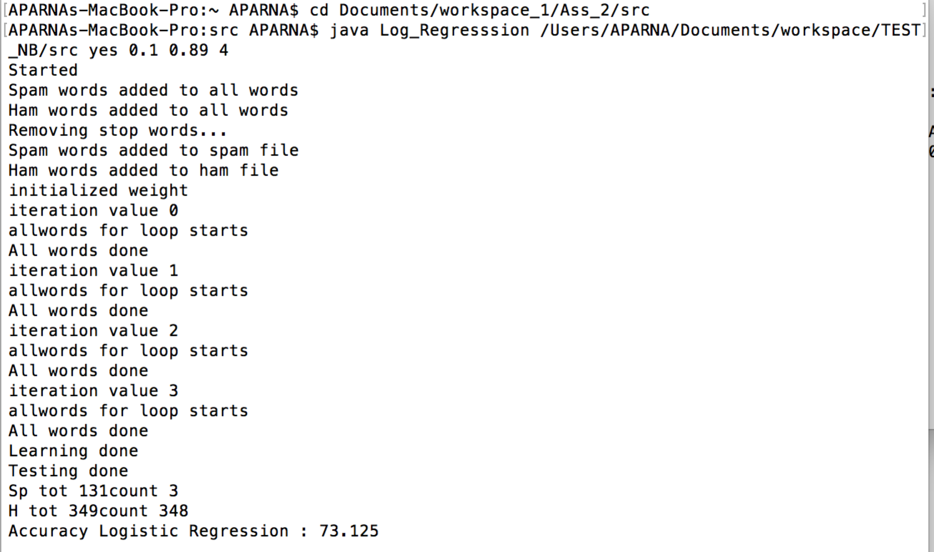

Iteration - 5

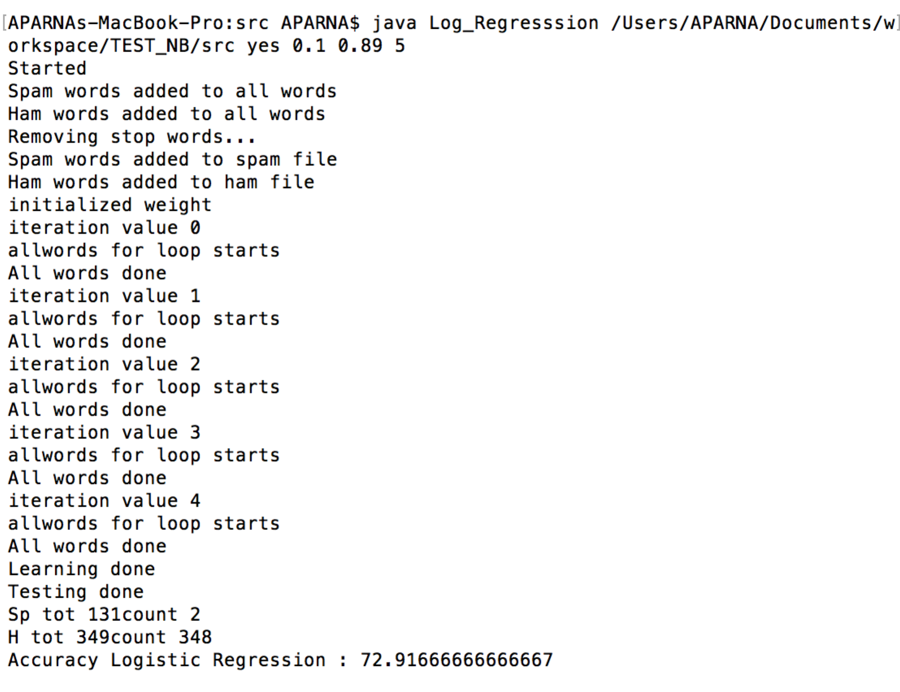

Iteration 6

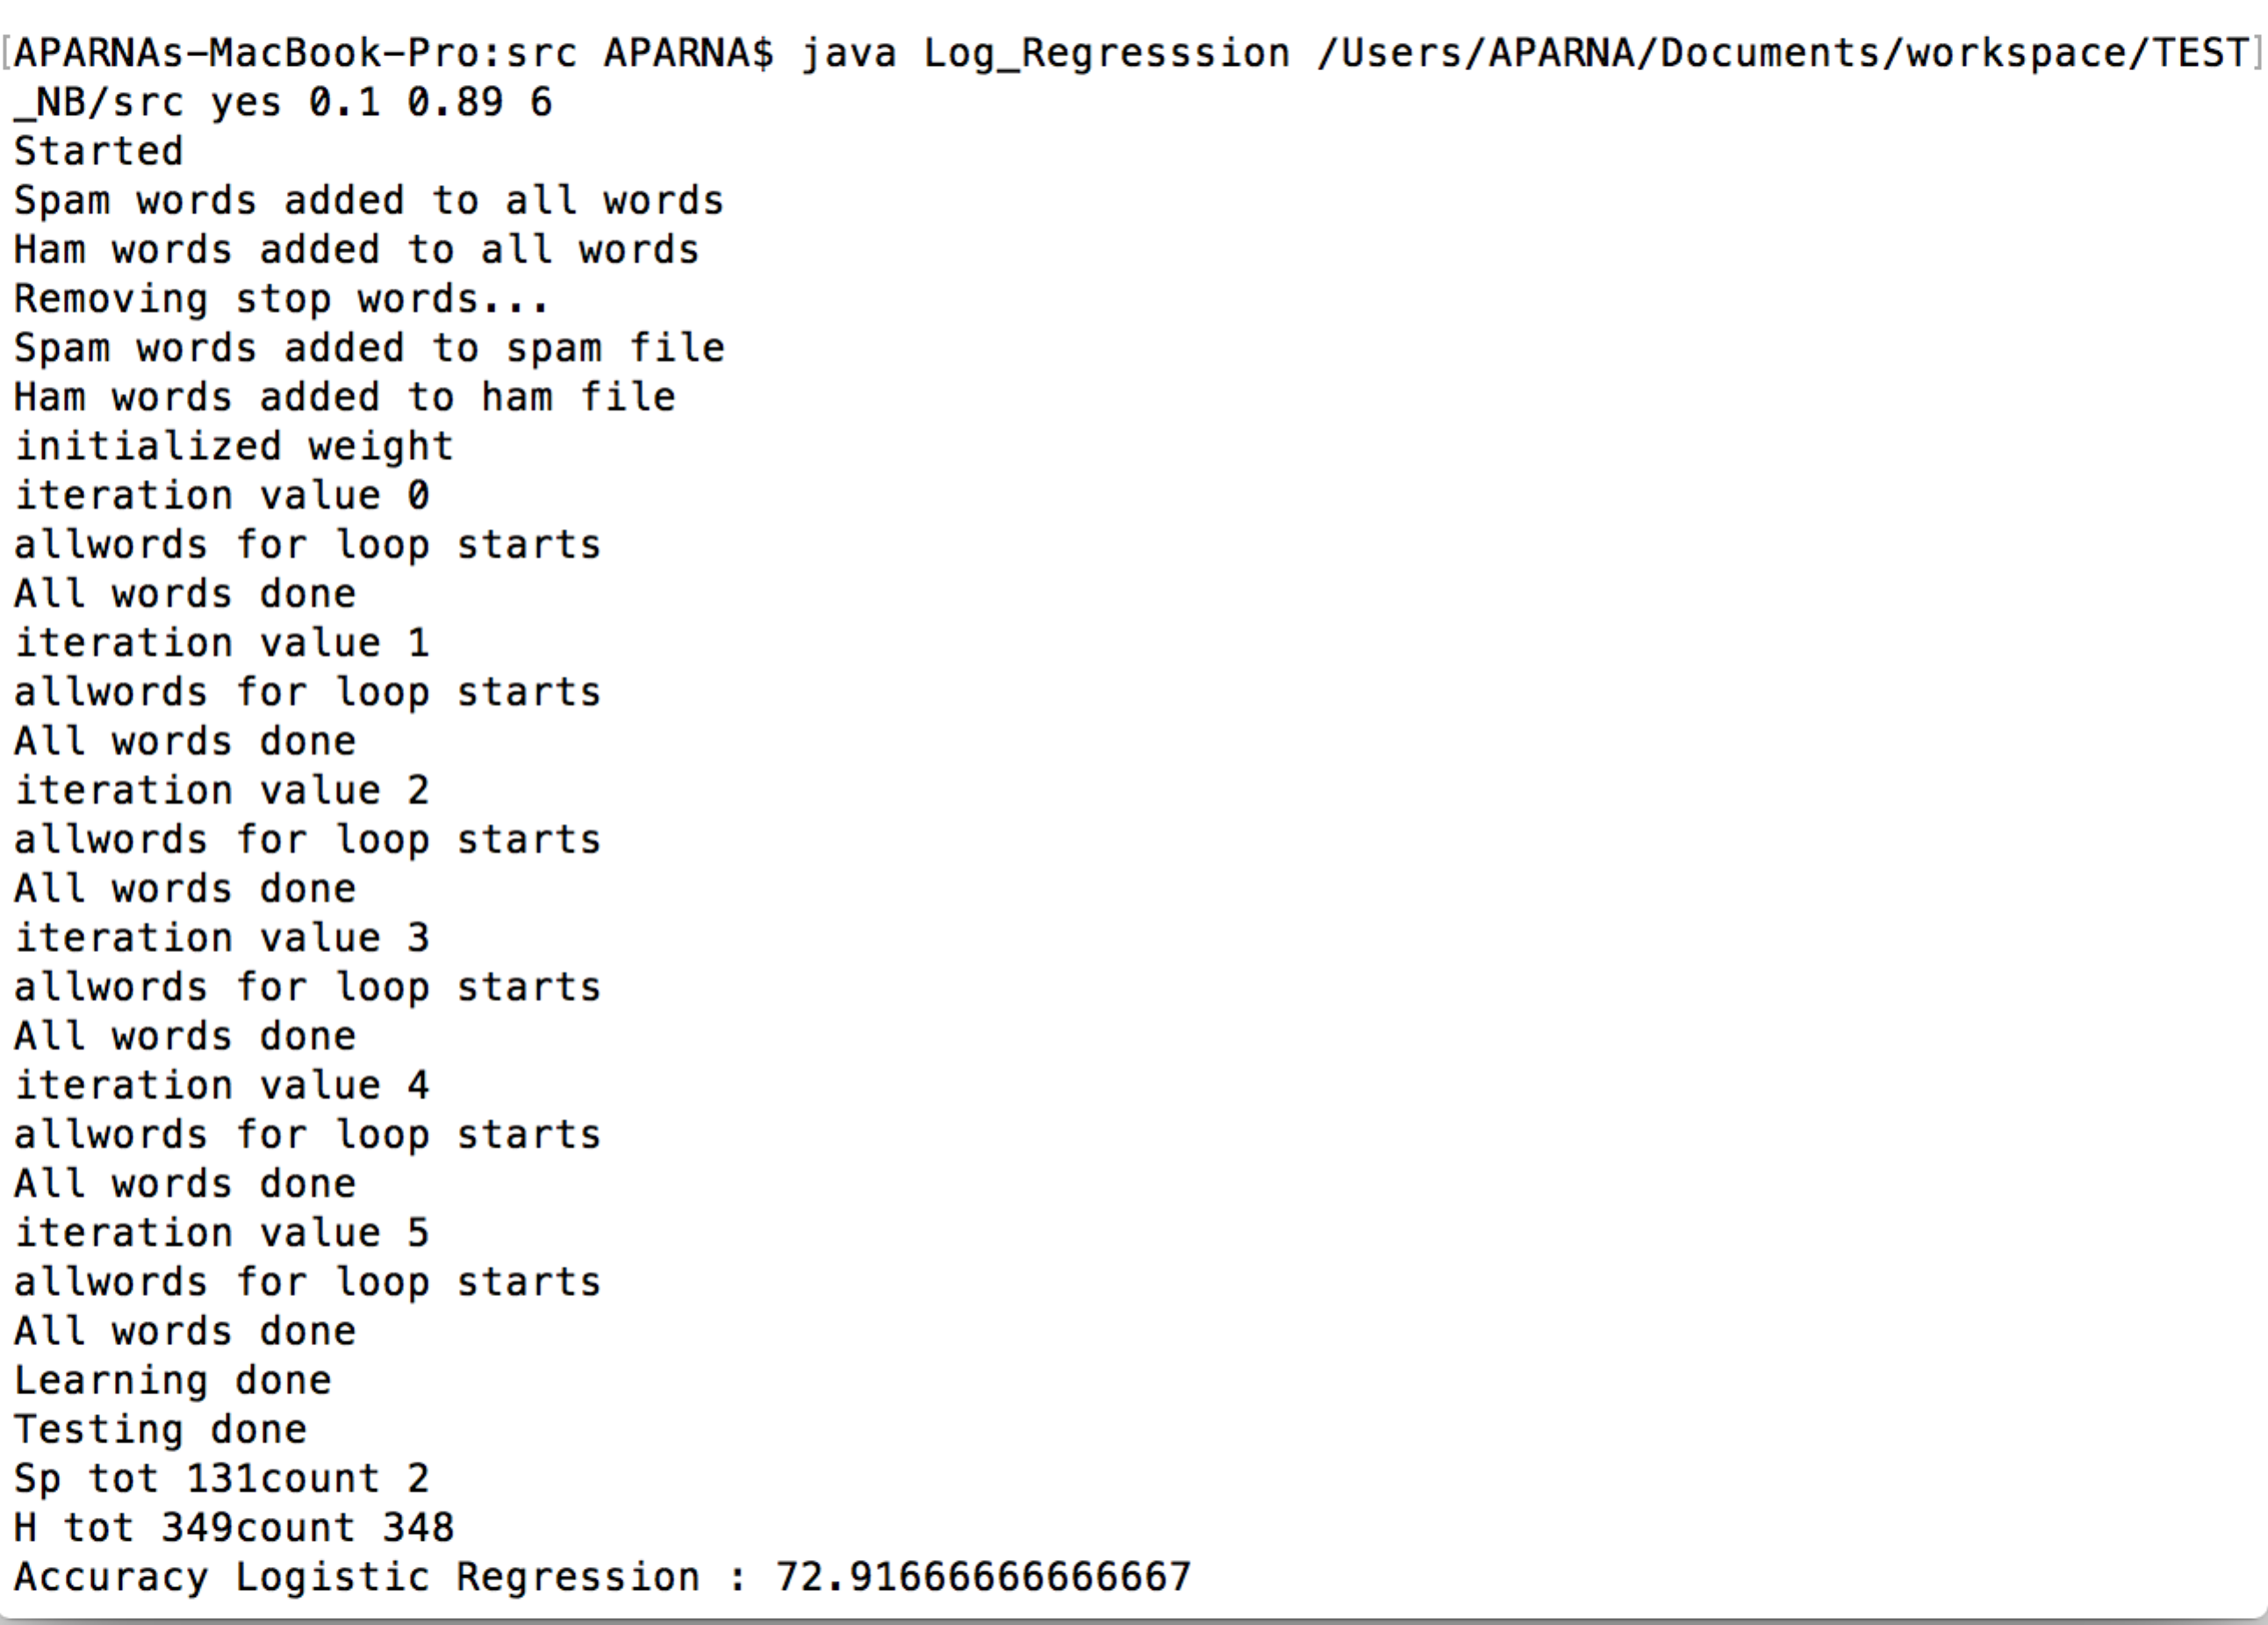

Program is considered on random weight error while starting, not a constant weight error, iteration number may vary depending on the random weight. It is converging in iteration 6.

**Example 2:**

Learning rate = .01

Lambda =.89

Iteration = 1

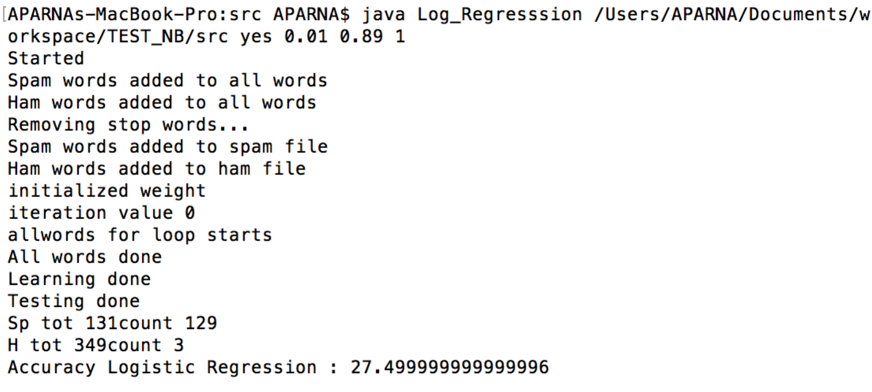

Iteration = 4

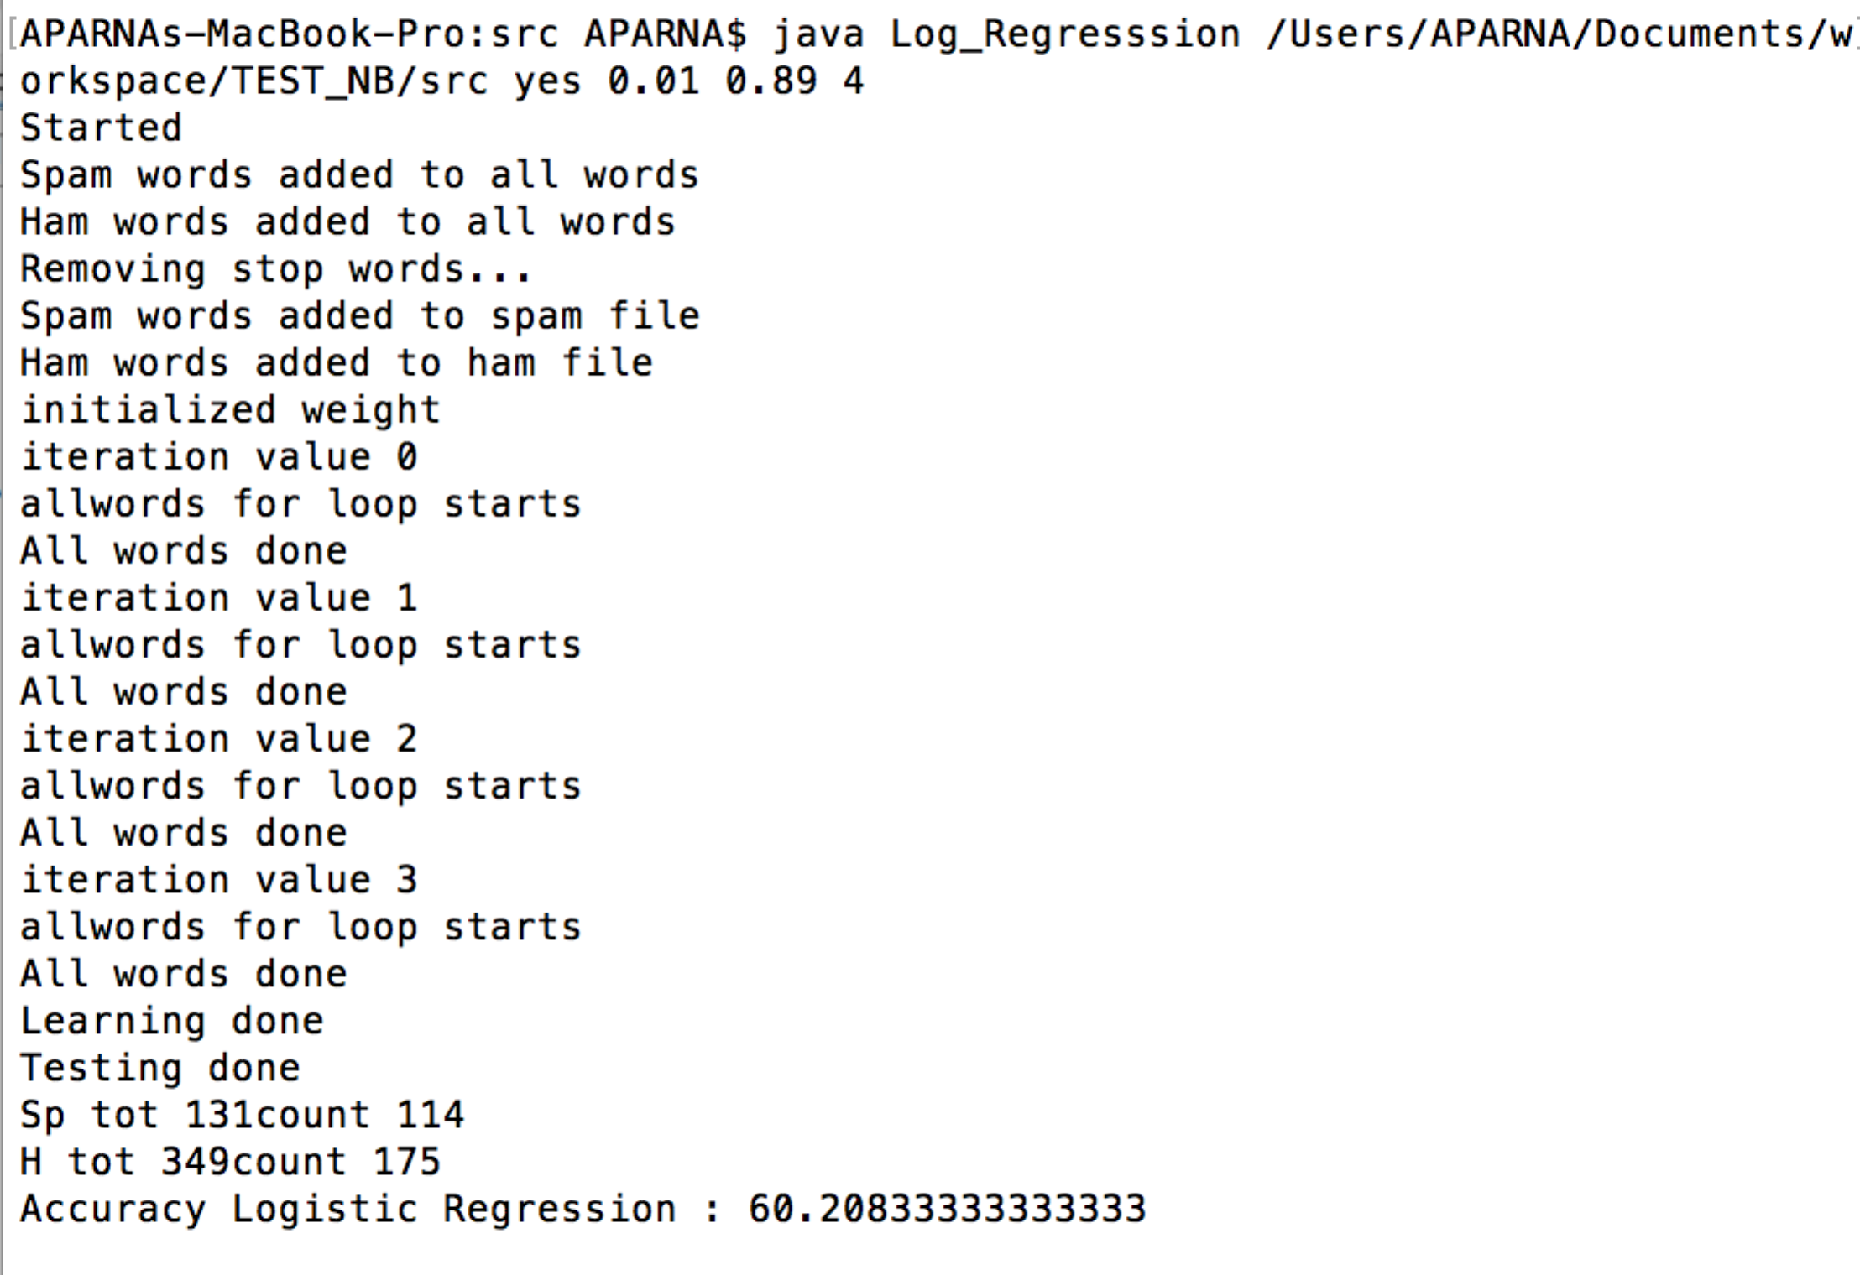

Iteration = 8

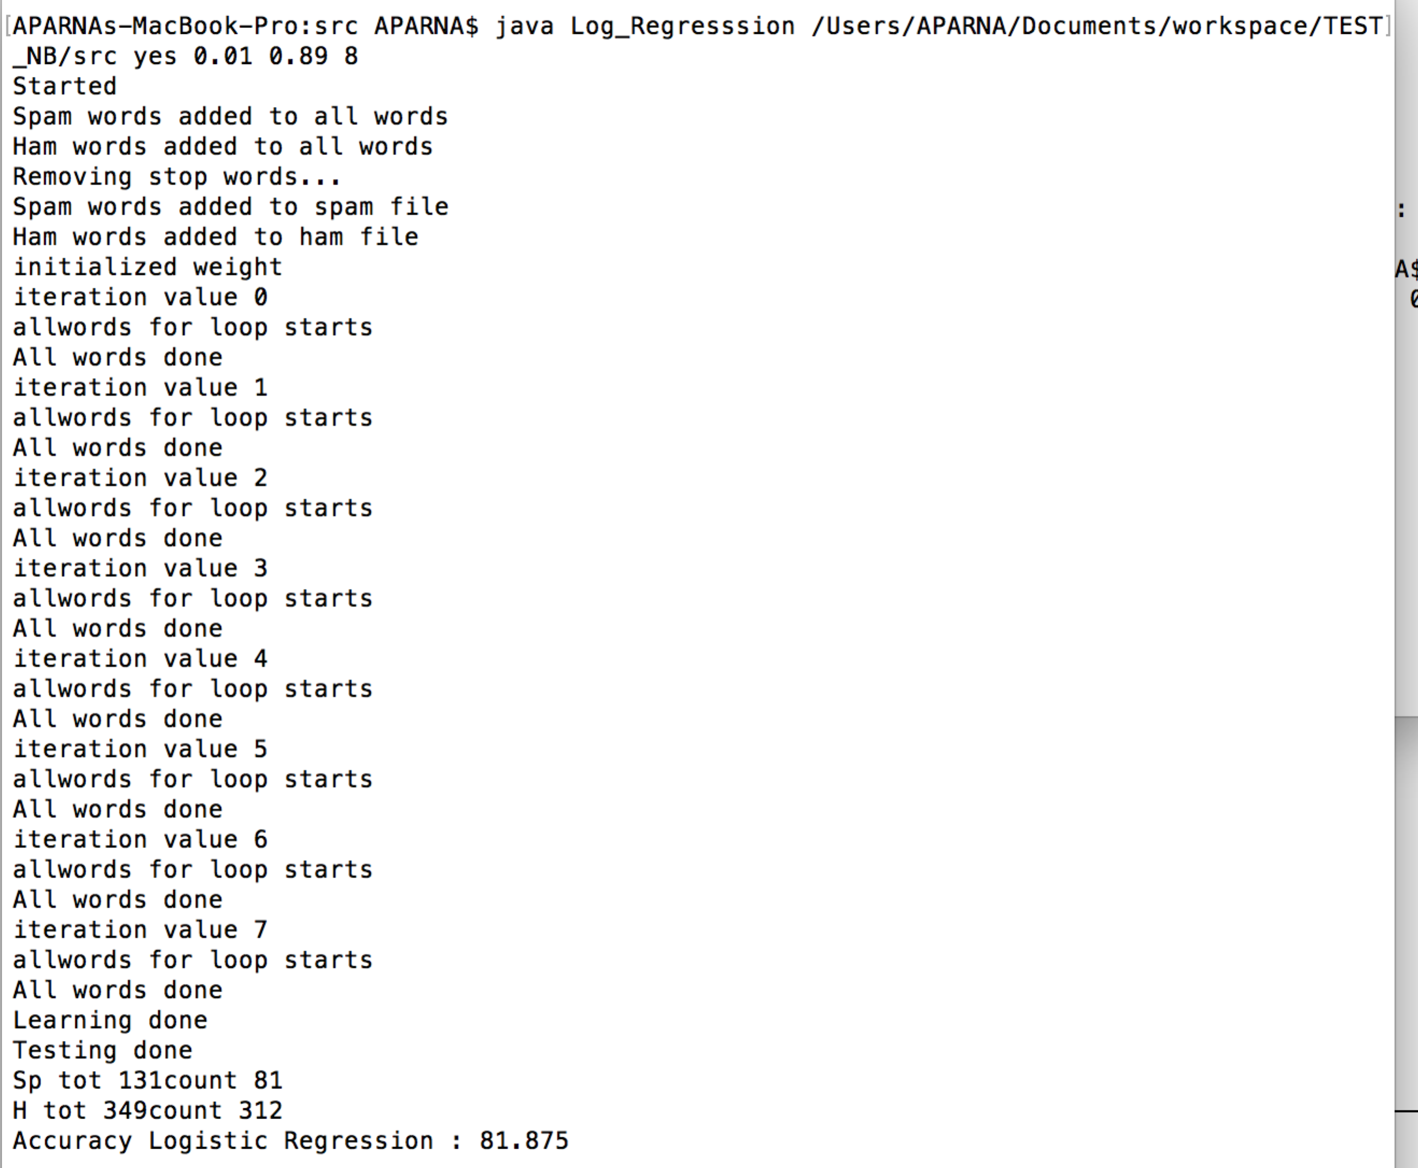

Iteration = 30

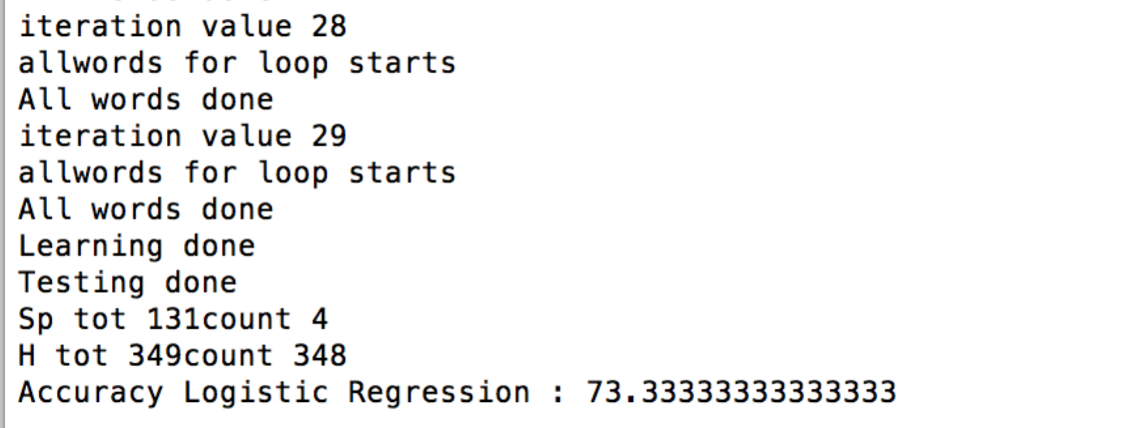

Example 3:

Learning rate = .9

Lambda =.9

Iteration = 1

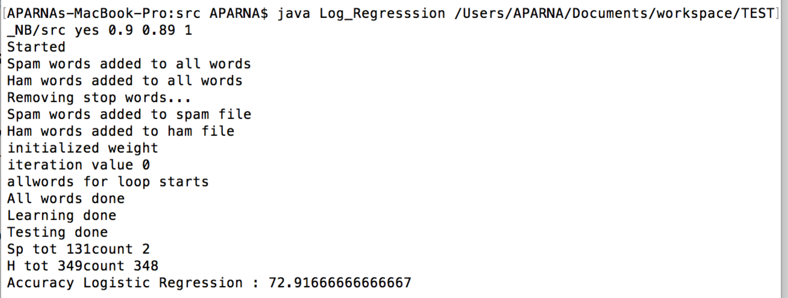

Iteration = 4

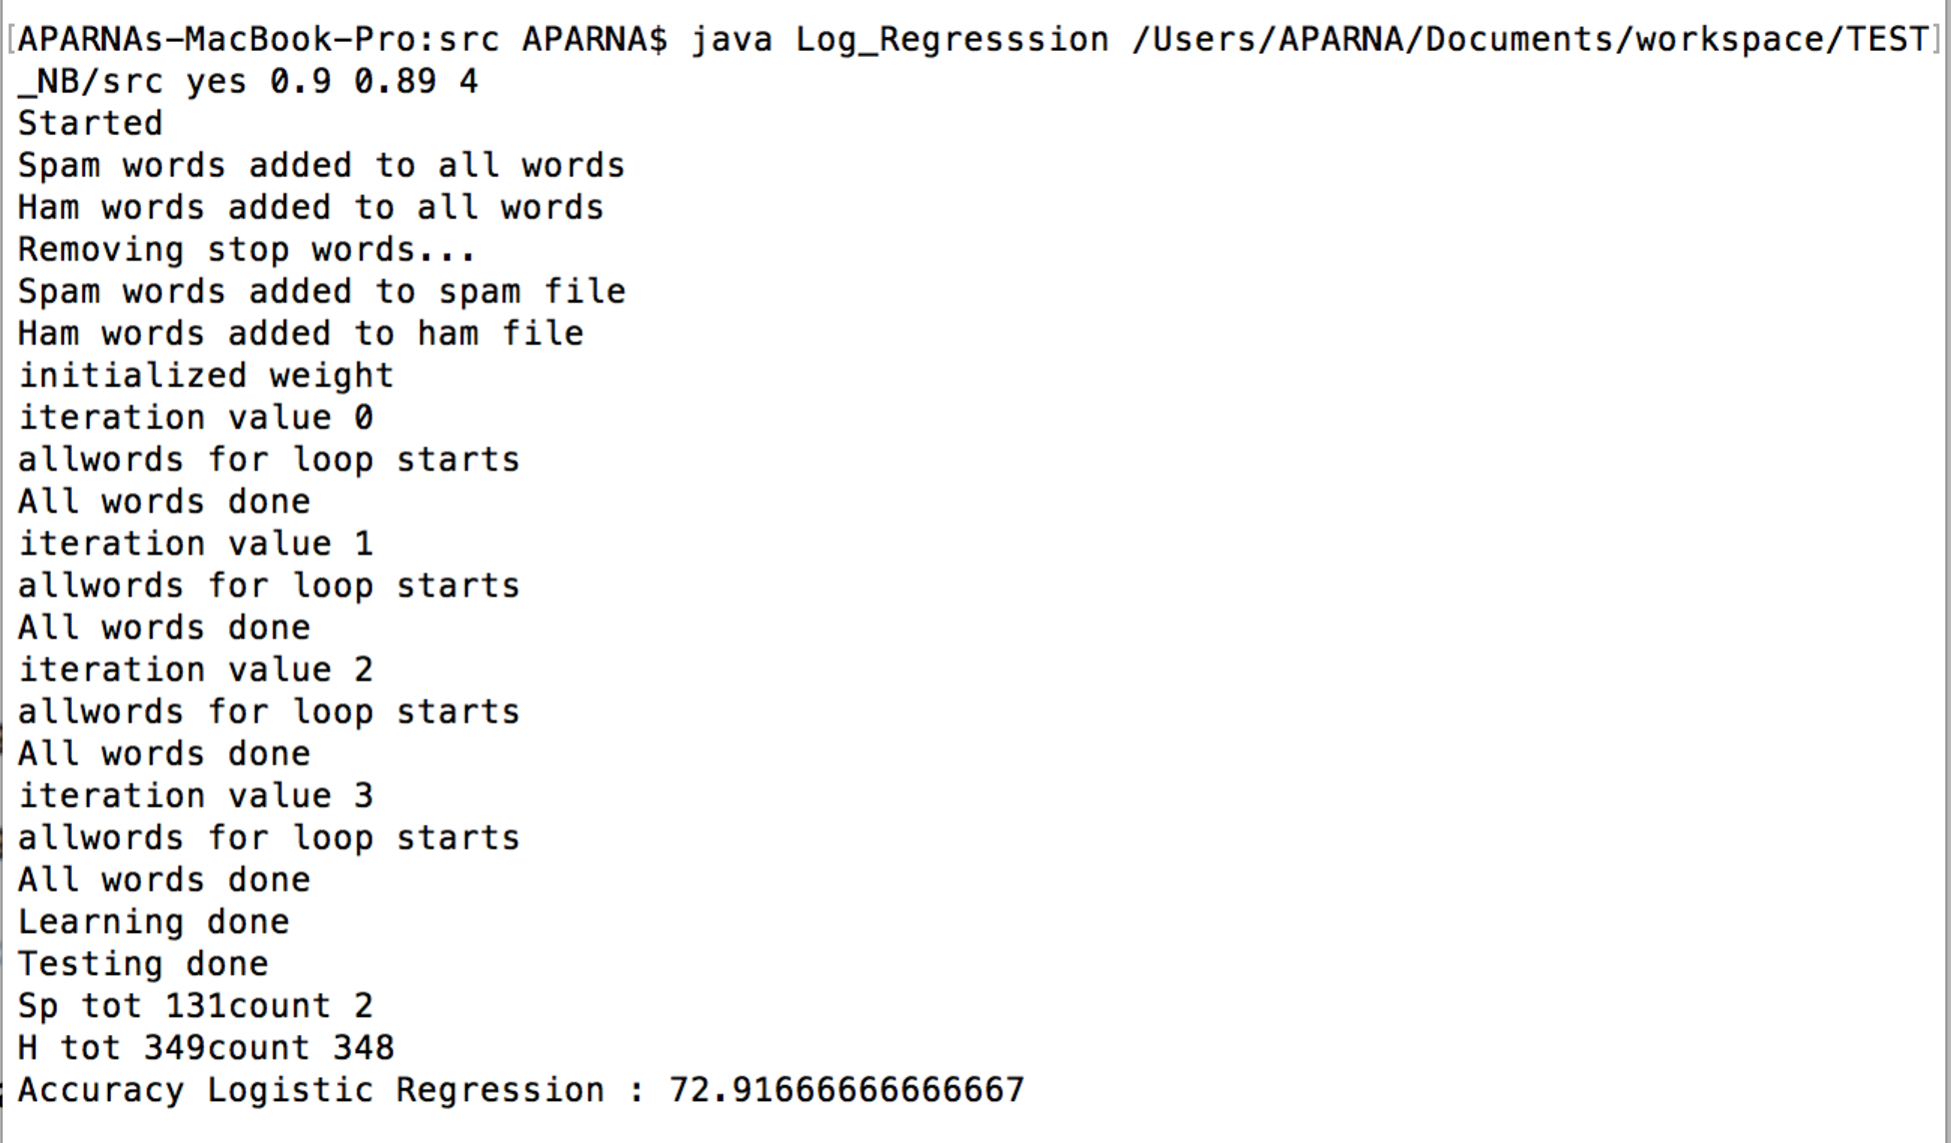

Iteration = 15

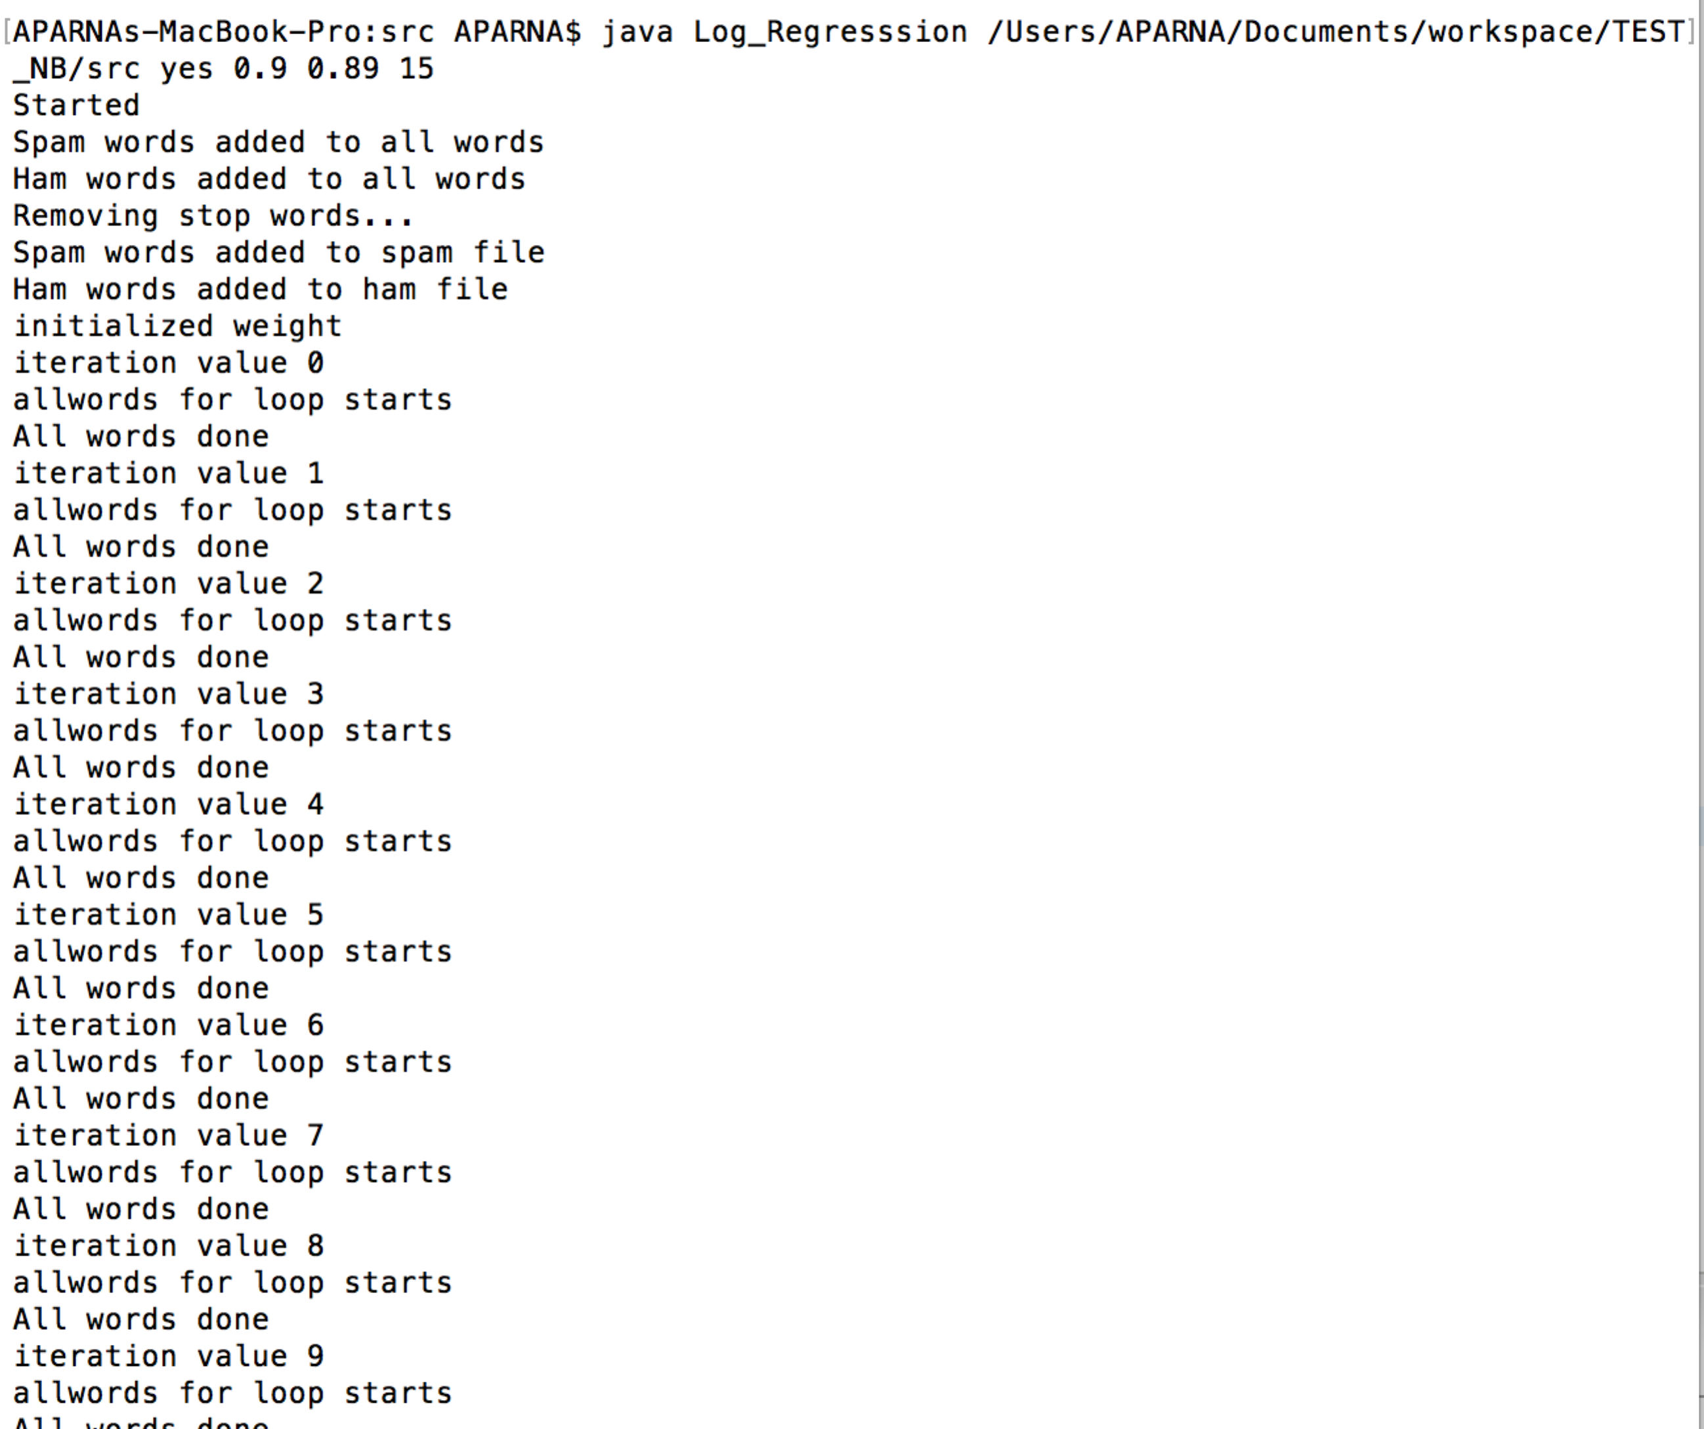

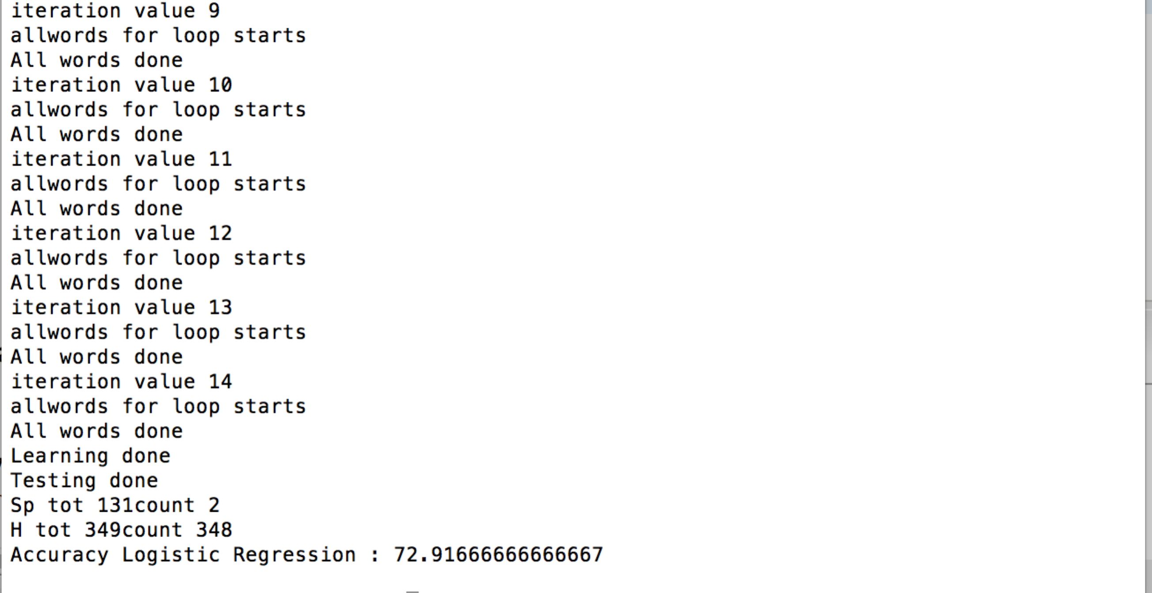

**Stop Words:** By removal of stop words from the data set, classification problem’s accuracy improved. Stop words removes unwanted and not important common words from data set hence it improves the accuracy.

**Special Symbols:** By including more special symbols, classification problem accuracy improved.

**Note:**  Weight of the words is generated as random values that mean each time program might start with different weight values. Hence iteration number of convergence and accuracy may vary a bit on different trials.